

BHARATI VIDYAPEETH’S
INSTITUTE OF COMPUTER APPLICATIONS & MANAGEMENT
(Affiliated to Guru Gobind Singh Indraprastha University, Approved by AICTE, New Delhi)

Design And Analysis of Algorithm

PRACTICAL FILE

Submitted To: | Submitted By:
Dr. Saumya Bansal | Asmi Gupta (35811604424)
 | MCA 3rd Sem, Section B

INDEX

Sr. No | Problem Description | Signature
P1 | Write a program to implement bubble sort
P2 | Write a program to implement quick sort.
P3 | Write a program to implement merge sort.
P4 | Write a program to implement binary search on the given list of values.
P5 | Write a program to perform radix sort on a given list of numbers.
P6 | Write a program to perform bucket sort on a given list of numbers.
P7 | Write a program to perform counting sort on a given list of numbers.
P8 | Given two matrices, perform Strassen’s matrix multiplication.
P9 | To Implement Matrix Chain Multiplication.
P10 | Write a program to perform a naïve string matching algorithm.
P11 | Implement and analyze the disjoint data structure algorithm.
P12 | Implement fractional Knapsack using Greedy approach and analyze the algorithm.
P13 | To implement Huffman Coding and analyze its time complexity
P14 | Implement the Dijkstra Algorithm using Greedy and analyze the algorithm.
P15 | Implement the Prims’ and Kruskal Algorithm using Greedy and analyze the algorithm.
P16 | Implement the Longest Common Subsequence using Dynamic Programming and analyze the algorithm.
P17 | Implement Matrix Chain Multiplication using Dynamic Programming and analyze the algorithm.
P18 | Implement Floyd-Warshell algorithm for a given graph.
A1 | WAP to solve N-Queens problem.
A2 | WAP to solve sum of subsets problem for a given set of distinct numbers.
A3 | WAP to find solution for job sequencing with deadlines problem.
A4 | WAP to implement Knuth Morris Pratt algorithm.

P1. Write a program to implement bubble sort.

#include <iostream>
using namespace std;

void bubbleSort(int arr[], int n)
{
for (int i = 0; i < n - 1; i++)
{
for (int j = 0; j < n - i - 1; j++)
{
if (arr[j] > arr[j + 1])
{
swap(arr[j], arr[j + 1]);
}
}
}
}

void printArray(int arr[], int size)
{
for (int i = 0; i < size; i++)
cout << arr[i] << " ";
cout << endl;
}

int main()
{
int arr[] = {64, 34, 25, 12, 22, 11, 90};
int n = sizeof(arr) / sizeof(arr[0]);

bubbleSort(arr, n);

cout << "Sorted array:\n";
printArray(arr, n);

return 0;
}
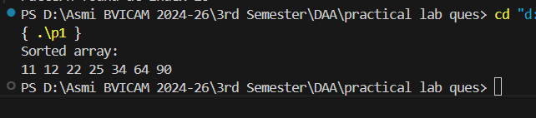

P2. Write a program to implement quick sort.
#include <iostream>
using namespace std;

int partition(int arr[], int low, int high)
{
int pivot = arr[high];
int i = (low - 1);

for (int j = low; j < high; j++)
{
if (arr[j] < pivot)
{
i++;
swap(arr[i], arr[j]);
}
}

swap(arr[i + 1], arr[high]);
return (i + 1);
}

void quickSort(int arr[], int low, int high)
{
if (low < high)
{
int pi = partition(arr, low, high);

quickSort(arr, low, pi - 1);
quickSort(arr, pi + 1, high);
}
}

void printArray(int arr[], int size)
{
for (int i = 0; i < size; i++)
cout << arr[i] << " ";
cout << endl;
}

int main()
{
int arr[] = {10, 7, 8, 9, 1, 5};
int n = sizeof(arr) / sizeof(arr[0]);

quickSort(arr, 0, n - 1);

cout << "Sorted array:\n";
printArray(arr, n);

return 0;
}

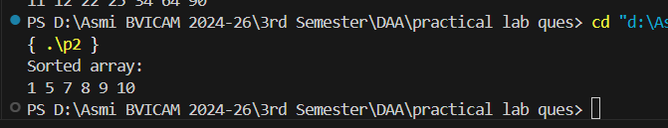

P3. Write a program to implement merge sort.

#include <iostream>
using namespace std;

void merge(int arr[], int l, int m, int r)
{
int n1 = m - l + 1;
int n2 = r - m;

int L[n1], R[n2];

for (int i = 0; i < n1; i++)
L[i] = arr[l + i];

for (int j = 0; j < n2; j++)
R[j] = arr[m + 1 + j];

int i = 0, j = 0, k = l;

while (i < n1 && j < n2)
{
if (L[i] <= R[j])
{
arr[k] = L[i];
i++;
}
else
{
arr[k] = R[j];
j++;
}
k++;
}

while (i < n1)
{
arr[k] = L[i];
i++;
k++;
}

while (j < n2)
{
arr[k] = R[j];
j++;
k++;
}
}

void mergeSort(int arr[], int l, int r)
{
if (l < r)
{
int m = l + (r - l) / 2;

mergeSort(arr, l, m);
mergeSort(arr, m + 1, r);

merge(arr, l, m, r);
}
}

void printArray(int arr[], int size)
{
for (int i = 0; i < size; i++)
cout << arr[i] << " ";
cout << endl;
}

int main()
{
int arr[] = {12, 11, 13, 5, 6, 7};
int arr_size = sizeof(arr) / sizeof(arr[0]);

cout << "Given array is \n";
printArray(arr, arr_size);

mergeSort(arr, 0, arr_size - 1);

cout << "\nSorted array is \n";
printArray(arr, arr_size);

return 0;
}

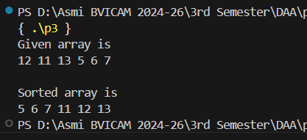

P4. Write a program to implement binary search on the given list of values.

#include <iostream>
using namespace std;

int binarySearch(int arr[], int l, int r, int x)
{
while (l <= r)
{
int m = l + (r - l) / 2;

if (arr[m] == x)
return m;

if (arr[m] < x)
l = m + 1;
else
r = m - 1;
}
return -1;
}

int main()
{
int arr[] = {2, 3, 4, 10, 40};
int n = sizeof(arr) / sizeof(arr[0]);
int x = 10;

int result = binarySearch(arr, 0, n - 1, x);

if (result == -1)
cout << "Element is not present in array\n";
else
cout << "Element is present at index " << result << endl;

return 0;
}

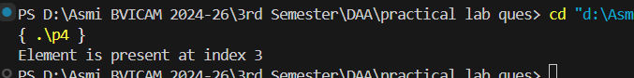

P5. Write a program to perform radix sort on a given list of number

#include <iostream>
using namespace std;

int getMax(int arr[], int n)
{
int mx = arr[0];
for (int i = 1; i < n; i++)
if (arr[i] > mx)
mx = arr[i];
return mx;
}

void countSort(int arr[], int n, int exp)
{
int output[n];
int count[10] = {0};

for (int i = 0; i < n; i++)
count[(arr[i] / exp) % 10]++;

for (int i = 1; i < 10; i++)
count[i] += count[i - 1];

for (int i = n - 1; i >= 0; i--)
{
output[count[(arr[i] / exp) % 10] - 1] = arr[i];
count[(arr[i] / exp) % 10]--;
}

for (int i = 0; i < n; i++)
arr[i] = output[i];
}

void radixSort(int arr[], int n)
{
int m = getMax(arr, n);

for (int exp = 1; m / exp > 0; exp *= 10)
countSort(arr, n, exp);
}

void printArray(int arr[], int n)
{
for (int i = 0; i < n; i++)
cout << arr[i] << " ";
cout << endl;
}

int main()
{
int arr[] = {170, 45, 75, 90, 802, 24, 2, 66};
int n = sizeof(arr) / sizeof(arr[0]);

radixSort(arr, n);

cout << "Sorted array:\n";
printArray(arr, n);

return 0;
}

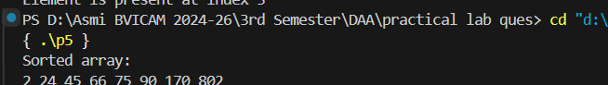

P6. Write a program to perform bucket sort on a given list of numbers.

#include <iostream>
#include <vector>
#include <algorithm>
using namespace std;

void bucketSort(float arr[], int n)
{
vector<float> b[n];

for (int i = 0; i < n; i++)
{
int bi = n * arr[i];
b[bi].push_back(arr[i]);
}

for (int i = 0; i < n; i++)
sort(b[i].begin(), b[i].end());

int index = 0;
for (int i = 0; i < n; i++)
for (int j = 0; j < b[i].size(); j++)
arr[index++] = b[i][j];
}

void printArray(float arr[], int n)
{
for (int i = 0; i < n; i++)
cout << arr[i] << " ";
cout << endl;
}

int main()
{
float arr[] = {0.897, 0.565, 0.656, 0.1234, 0.665, 0.3434};
int n = sizeof(arr) / sizeof(arr[0]);

bucketSort(arr, n);

cout << "Sorted array:\n";
printArray(arr, n);

return 0;
}

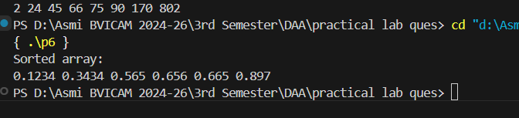

P7. Write a program to perform counting sort on a given list of numbers.

#include <iostream>
using namespace std;

void countSort(int arr[], int n)
{
int output[n];

int max = arr[0];
for (int i = 1; i < n; i++)
if (arr[i] > max)
max = arr[i];

int count[max + 1] = {0};

for (int i = 0; i < n; i++)
count[arr[i]]++;

for (int i = 1; i <= max; i++)
count[i] += count[i - 1];

for (int i = n - 1; i >= 0; i--)
{
output[count[arr[i]] - 1] = arr[i];
count[arr[i]]--;
}

for (int i = 0; i < n; i++)
arr[i] = output[i];
}

void printArray(int arr[], int n)
{
for (int i = 0; i < n; i++)
cout << arr[i] << " ";
cout << endl;
}

int main()
{
int arr[] = {1, 4, 1, 2, 7, 5, 2};
int n = sizeof(arr) / sizeof(arr[0]);

countSort(arr, n);

cout << "Sorted array:\n";
printArray(arr, n);

return 0;
}

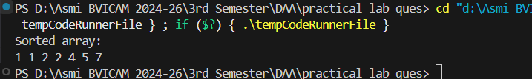

P8. Given two matrices, perform Strassen’s matrix multiplication.

#include <iostream>
using namespace std;

void strassenMultiply(int A[2][2], int B[2][2], int C[2][2])
{
int M1 = (A[0][0] + A[1][1]) * (B[0][0] + B[1][1]);
int M2 = (A[1][0] + A[1][1]) * B[0][0];
int M3 = A[0][0] * (B[0][1] - B[1][1]);
int M4 = A[1][1] * (B[1][0] - B[0][0]);
int M5 = (A[0][0] + A[0][1]) * B[1][1];
int M6 = (A[1][0] - A[0][0]) * (B[0][0] + B[0][1]);
int M7 = (A[0][1] - A[1][1]) * (B[1][0] + B[1][1]);

C[0][0] = M1 + M4 - M5 + M7;
C[0][1] = M3 + M5;
C[1][0] = M2 + M4;
C[1][1] = M1 - M2 + M3 + M6;
}

void printMatrix(int C[2][2])
{
for (int i = 0; i < 2; i++)
{
for (int j = 0; j < 2; j++)
cout << C[i][j] << " ";
cout << endl;
}
}

int main()
{
int A[2][2] = {
{1, 2},
{3, 4}};

int B[2][2] = {
{5, 6},
{7, 8}};

int C[2][2];

strassenMultiply(A, B, C);

cout << "Product of matrices:\n";
printMatrix(C);

return 0;
}

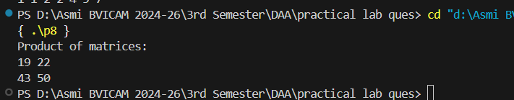

P9. WAP to Implement Matrix Chain Multiplication.
#include <iostream>
#include <limits.h>
using namespace std;

int matrixChainOrder(int p[], int n)
{
int m[n][n];

for (int i = 1; i < n; i++)
m[i][i] = 0;

for (int L = 2; L < n; L++)
{
for (int i = 1; i < n - L + 1; i++)
{
int j = i + L - 1;
m[i][j] = INT_MAX;

for (int k = i; k <= j - 1; k++)
{
int q = m[i][k] + m[k + 1][j] + p[i - 1] * p[k] * p[j];

if (q < m[i][j])
m[i][j] = q;
}
}
}

return m[1][n - 1];
}

int main()
{
int arr[] = {1, 2, 3, 4};
int n = sizeof(arr) / sizeof(arr[0]);

cout << "Minimum number of multiplications is: "
<< matrixChainOrder(arr, n);

return 0;
}

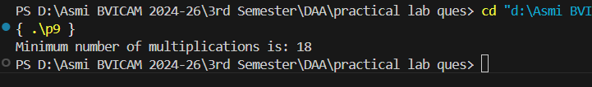

P10. Write a program to perform a naïve string-matching algorithm.

#include <iostream>
#include <string>
using namespace std;

void naiveSearch(string txt, string pat)
{
int M = pat.length();
int N = txt.length();

for (int i = 0; i <= N - M; i++)
{
int j;

for (j = 0; j < M; j++)
if (txt[i + j] != pat[j])
break;

if (j == M)
cout << "Pattern found at index " << i << endl;
}
}

int main()
{
string txt = "AABAACAADAABAABA";
string pat = "AABA";

naiveSearch(txt, pat);

return 0;
}

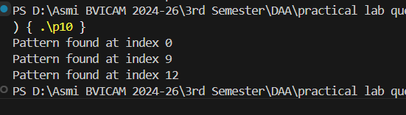

P11. Implement and analyse the disjoint data structure algorithm.

#include <iostream>
using namespace std;

class DisjointSet
{
int *parent, *rank;
int n;

public:
DisjointSet(int n)
{
this->n = n;
parent = new int[n + 1];
rank = new int[n + 1];

for (int i = 0; i <= n; i++)
{
parent[i] = i;
rank[i] = 0;
}
}

int find(int u)
{
if (u != parent[u])
parent[u] = find(parent[u]); // Path compression
return parent[u];
}

void unionSets(int u, int v)
{
u = find(u);
v = find(v);

if (u == v)
return;

if (rank[u] > rank[v])
parent[v] = u;
else if (rank[u] < rank[v])
parent[u] = v;
else
{
parent[v] = u;
rank[u]++;
}
}
};

int main()
{
DisjointSet ds(5);

ds.unionSets(1, 2);
ds.unionSets(3, 4);
ds.unionSets(2, 3);

cout << "1 and 3 are in the same set? "
<< (ds.find(1) == ds.find(3)) << endl;

return 0;
}

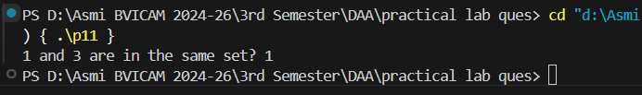

P12. Implement fractional Knapsack using Greedy approach and analyse the algorithm.

// Implement fractional Knapsack using Greedy approach and analyze the algorithm.

#include <iostream>
using namespace std;

struct Item
{
int value, weight;
};

// Function to sort items by value/weight ratio
void sortItemsByValuePerWeight(Item arr[], int n)
{
for (int i = 0; i < n - 1; i++)
{
for (int j = i + 1; j < n; j++)
{
double r1 = (double)arr[i].value / arr[i].weight;
double r2 = (double)arr[j].value / arr[j].weight;

if (r1 < r2)
{
Item temp = arr[i];
arr[i] = arr[j];
arr[j] = temp;
}
}
}
}

double fractionalKnapsack(int W, Item arr[], int n)
{
sortItemsByValuePerWeight(arr, n);

int curWeight = 0;
double finalValue = 0.0;

for (int i = 0; i < n; i++)
{

if (curWeight + arr[i].weight <= W)
{
curWeight += arr[i].weight;
finalValue += arr[i].value;
}
else
{
int remain = W - curWeight;
finalValue += arr[i].value * ((double)remain / arr[i].weight);
break;
}
}
return finalValue;
}

int main()
{
Item arr[] = {{60, 10}, {100, 20}, {120, 30}};
int W = 50;
int n = 3;

cout << "Maximum value in Knapsack = "
<< fractionalKnapsack(W, arr, n) << endl;

return 0;
}

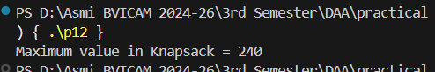

P13. WAP to implement Huffman Coding and analyse itstime complexity.

#include <iostream>
using namespace std;

struct Node
{
char ch;
int freq;
Node *left, *right;

Node(char ch, int freq)
{
this->ch = ch;
this->freq = freq;
left = right = nullptr;
}
};

void printCodes(Node *root, char code[], int top)
{
if (root->left)
{
code[top] = '0';
printCodes(root->left, code, top + 1);
}
if (root->right)
{
code[top] = '1';
printCodes(root->right, code, top + 1);
}
if (!root->left && !root->right)
{
cout << root->ch << ": ";
for (int i = 0; i < top; i++)
cout << code[i];
cout << endl;
}
}

void buildHuffmanTree(char data[], int freq[], int size)
{
Node *nodes[10];

for (int i = 0; i < size; i++)
{
nodes[i] = new Node(data[i], freq[i]);
}

// Build Huffman tree manually
for (int count = 0; count < size - 1; count++)
{

int min1 = -1, min2 = -1;

// Find two smallest frequencies
for (int i = 0; i < size; i++)
{
if (nodes[i] == nullptr)
continue;

if (min1 == -1 || nodes[i]->freq < nodes[min1]->freq)
{
min2 = min1;
min1 = i;
}
else if (min2 == -1 || nodes[i]->freq < nodes[min2]->freq)
{
min2 = i;
}
}

// Merge nodes
Node *top = new Node('$', nodes[min1]->freq + nodes[min2]->freq);
top->left = nodes[min1];
top->right = nodes[min2];

nodes[min1] = top;
nodes[min2] = nullptr;
}

Node *root = nullptr;
for (int i = 0; i < size; i++)
if (nodes[i] != nullptr)
root = nodes[i];

char code[20];
printCodes(root, code, 0);
}

int main()
{
char arr[] = {'a', 'b', 'c', 'd', 'e', 'f'};
int freq[] = {5, 9, 12, 13, 16, 45};
int size = 6;

buildHuffmanTree(arr, freq, size);

return 0;
}

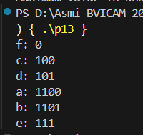

P14. Implement the Dijkstra Algorithm using Greedy and analyze the algorithm.

#include <iostream>
using namespace std;

int minDistance(int dist[], bool sptSet[], int V)
{
int min = 10000, min_index = -1;

for (int v = 0; v < V; v++)
if (!sptSet[v] && dist[v] <= min)
min = dist[v], min_index = v;

return min_index;
}

void dijkstra(int graph[9][9], int src, int V)
{
int dist[V];
bool sptSet[V];

for (int i = 0; i < V; i++)
dist[i] = 10000, sptSet[i] = false;

dist[src] = 0;

for (int count = 0; count < V - 1; count++)
{
int u = minDistance(dist, sptSet, V);
sptSet[u] = true;

for (int v = 0; v < V; v++)
if (!sptSet[v] && graph[u][v] != 0 &&
dist[u] != 10000 &&
dist[u] + graph[u][v] < dist[v])
dist[v] = dist[u] + graph[u][v];
}

cout << "Vertex \t Distance from Source\n";
for (int i = 0; i < V; i++)
cout << i << " \t\t " << dist[i] << endl;
}

int main()
{
int graph[9][9] = {
{0, 4, 0, 0, 0, 0, 0, 8, 0},
{4, 0, 8, 0, 0, 0, 0, 11, 0},
{0, 8, 0, 7, 0, 4, 0, 0, 2},
{0, 0, 7, 0, 9, 14, 0, 0, 0},
{0, 0, 0, 9, 0, 10, 0, 0, 0},
{0, 0, 4, 14, 10, 0, 2, 0, 0},
{0, 0, 0, 0, 0, 2, 0, 1, 6},
{8, 11, 0, 0, 0, 0, 1, 0, 7},
{0, 0, 2, 0, 0, 0, 6, 7, 0}};

dijkstra(graph, 0, 9);

return 0;
}

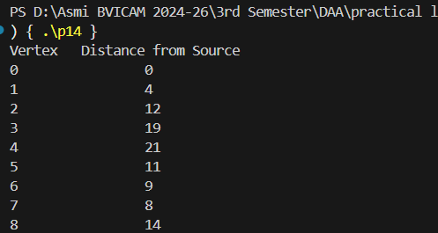

P15. Implement the Prims’ and Kruskal Algorithm using Greedy and analyse the algorithm.

Prims’:

#include <iostream>
using namespace std;

#define V 5 // Number of vertices

int minKey(int key[], bool mstSet[])
{
int min = 10000, min_index = -1;

for (int v = 0; v < V; v++)
if (!mstSet[v] && key[v] < min)
min = key[v], min_index = v;

return min_index;
}

void printMST(int parent[], int graph[V][V])
{
cout << "Edge \tWeight\n";
for (int i = 1; i < V; i++)
cout << parent[i] << " - " << i << " \t" << graph[i][parent[i]] << "\n";
}

void primMST(int graph[V][V])
{
int parent[V];
int key[V];
bool mstSet[V];

for (int i = 0; i < V; i++)
key[i] = 10000, mstSet[i] = false;

key[0] = 0;
parent[0] = -1;

for (int count = 0; count < V - 1; count++)
{
int u = minKey(key, mstSet);
mstSet[u] = true;

for (int v = 0; v < V; v++)
if (graph[u][v] && !mstSet[v] && graph[u][v] < key[v])
{
parent[v] = u;
key[v] = graph[u][v];
}
}

printMST(parent, graph);
}

int main()
{
int graph[V][V] = {
{0, 2, 0, 6, 0},
{2, 0, 3, 8, 5},
{0, 3, 0, 0, 7},
{6, 8, 0, 0, 9},
{0, 5, 7, 9, 0}};

primMST(graph);

return 0;
}

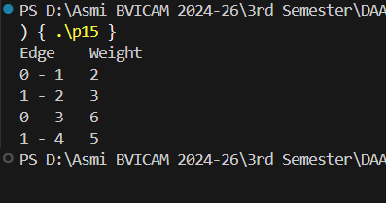

Kruskal:

#include <iostream>
using namespace std;

struct Edge
{
int src, dest, weight;
};

void sortEdges(Edge edges[], int E)
{
for (int i = 0; i < E - 1; i++)
{
for (int j = i + 1; j < E; j++)
{
if (edges[i].weight > edges[j].weight)
{
Edge temp = edges[i];
edges[i] = edges[j];
edges[j] = temp;
}
}
}
}

int find(int parent[], int i)
{
if (parent[i] == i)
return i;
return find(parent, parent[i]);
}

void Union(int parent[], int rank[], int x, int y)
{
int rootX = find(parent, x);
int rootY = find(parent, y);

if (rank[rootX] < rank[rootY])
parent[rootX] = rootY;
else if (rank[rootX] > rank[rootY])
parent[rootY] = rootX;
else
{
parent[rootY] = rootX;
rank[rootX]++;
}
}

void kruskalMST(Edge edges[], int V, int E)
{
sortEdges(edges, E);

int parent[V], rank[V];
for (int i = 0; i < V; i++)
{
parent[i] = i;
rank[i] = 0;
}

Edge result[V];
int e = 0;
int i = 0;

while (e < V - 1 && i < E)
{
Edge next_edge = edges[i++];

int x = find(parent, next_edge.src);
int y = find(parent, next_edge.dest);

if (x != y)
{
result[e++] = next_edge;
Union(parent, rank, x, y);
}
}

cout << "Edges in the MST:\n";
for (int j = 0; j < e; j++)
cout << result[j].src << " -- " << result[j].dest
<< " == " << result[j].weight << endl;
}

int main()
{
int V = 4;
int E = 5;

Edge edges[] = {
{0, 1, 10},
{0, 2, 6},
{0, 3, 5},
{1, 3, 15},
{2, 3, 4}};

kruskalMST(edges, V, E);

return 0;
}

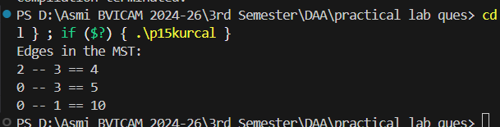

P16. Implement the Longest Common Subsequence using Dynamic Programming and analyse the algorithm.

#include <iostream>
using namespace std;

int max(int a, int b)
{
return (a > b) ? a : b;
}

int lcs(char X[], char Y[], int m, int n)
{
int L[100][100];

// Build table L[][] in bottom-up manner
for (int i = 0; i <= m; i++)
{
for (int j = 0; j <= n; j++)
{
if (i == 0 || j == 0)
L[i][j] = 0;
else if (X[i - 1] == Y[j - 1])
L[i][j] = L[i - 1][j - 1] + 1;
else
L[i][j] = max(L[i - 1][j], L[i][j - 1]);
}
}

return L[m][n];
}

void printLCS(char X[], char Y[], int m, int n)
{
int L[100][100];

// Build the DP table
for (int i = 0; i <= m; i++)
{
for (int j = 0; j <= n; j++)
{
if (i == 0 || j == 0)
L[i][j] = 0;
else if (X[i - 1] == Y[j - 1])
L[i][j] = L[i - 1][j - 1] + 1;
else
L[i][j] = max(L[i - 1][j], L[i][j - 1]);
}
}

// Length of LCS
int index = L[m][n];

char lcs[index + 1];
lcs[index] = '\0'; // null terminate

// Trace back to get LCS
int i = m, j = n;
while (i > 0 && j > 0)
{
if (X[i - 1] == Y[j - 1])
{
lcs[index - 1] = X[i - 1];
i--;
j--;
index--;
}
else if (L[i - 1][j] > L[i][j - 1])
i--;
else
j--;
}

cout << "LCS of " << X << " and " << Y << " is: " << lcs << endl;
}

int main()
{
char X[] = "AGGTAB";
char Y[] = "GXTXAYB";

int m = sizeof(X) / sizeof(X[0]) - 1;
int n = sizeof(Y) / sizeof(Y[0]) - 1;

cout << "Length of LCS is " << lcs(X, Y, m, n) << endl;

printLCS(X, Y, m, n);

return 0;
}

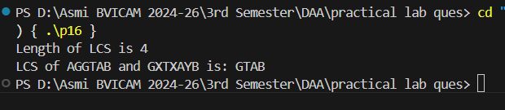

P17. Implement Matrix Chain Multiplication using Dynamic Programming and analyse the algorithm.

#include <iostream>
using namespace std;

int matrixChainMultiplication(int p[], int n)
{
int m[100][100];

// Cost is zero when multiplying one matrix
for (int i = 1; i < n; i++)
{
m[i][i] = 0;
}

// l = chain length
for (int l = 2; l < n; l++)
{
for (int i = 1; i < n - l + 1; i++)
{
int j = i + l - 1;
m[i][j] = 100000; // large value

for (int k = i; k <= j - 1; k++)
{
// q = cost
int q = m[i][k] + m[k + 1][j] + p[i - 1] * p[k] * p[j];

if (q < m[i][j])
{
m[i][j] = q;
}
}
}
}

return m[1][n - 1];
}
int main()
{
int arr[] = {1, 2, 3, 4}; // Dimensions: 1x2, 2x3, 3x4
int size = sizeof(arr) / sizeof(arr[0]);

cout << "Minimum number of multiplications is: "
<< matrixChainMultiplication(arr, size) << endl;

return 0;
}
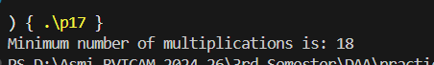

P18. Implement Floyd-Warshall algorithm for a given graph.

#include <iostream>
using namespace std;

#define INF 10000 // Infinity value

void floydWarshall(int graph[100][100], int V)
{
int dist[100][100];

// Initialize distance matrix equal to graph matrix
for (int i = 0; i < V; i++)
{
for (int j = 0; j < V; j++)
{
dist[i][j] = graph[i][j];
}
}

// Floyd-Warshall algorithm
for (int k = 0; k < V; k++)
{
for (int i = 0; i < V; i++)
{
for (int j = 0; j < V; j++)
{
if (dist[i][k] + dist[k][j] < dist[i][j])
{
dist[i][j] = dist[i][k] + dist[k][j];
}
}
}
}

// Print solution
cout << "Shortest distances between every pair of vertices:\n";
for (int i = 0; i < V; i++)
{
for (int j = 0; j < V; j++)
{
if (dist[i][j] == INF)
cout << "INF ";
else
cout << dist[i][j] << " ";
}
cout << endl;
}
}

int main()
{
int V = 4;
int graph[100][100] = {
{0, 5, INF, 10},
{INF, 0, 3, INF},
{INF, INF, 0, 1},
{INF, INF, INF, 0}};

floydWarshall(graph, V);
return 0;
}

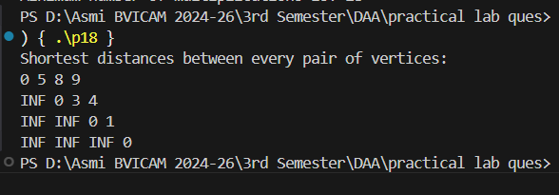

A1. Write a program to solve N-QUEENS problem.

#include <iostream>
using namespace std;

#define N 8 // Size of the chessboard

// Function to print the solution
void printSolution(int board[N][N])
{
for (int i = 0; i < N; i++)
{
for (int j = 0; j < N; j++)
cout << board[i][j] << " ";
cout << endl;
}
cout << endl;
}

// Check if a queen can be placed at board[row][col]
bool isSafe(int board[N][N], int row, int col)
{
int i, j;

// Check row on left side
for (i = 0; i < col; i++)
if (board[row][i])
return false;

// Check upper diagonal on left side
for (i = row, j = col; i >= 0 && j >= 0; i--, j--)
if (board[i][j])
return false;

// Check lower diagonal on left side
for (i = row, j = col; j >= 0 && i < N; i++, j--)
if (board[i][j])
return false;

return true;
}

// Recursive function to solve N Queens
bool solveNQUtil(int board[N][N], int col)
{
if (col >= N)
return true;

for (int i = 0; i < N; i++)
{

if (isSafe(board, i, col))
{
board[i][col] = 1; // Place queen

if (solveNQUtil(board, col + 1))
return true;

board[i][col] = 0; // BACKTRACK
}
}

return false;
}

bool solveNQ()
{
int board[N][N] = {0}; // Initialize all cells to 0

if (!solveNQUtil(board, 0))
{
cout << "Solution does not exist" << endl;
return false;
}

printSolution(board);
return true;
}

int main()
{
solveNQ();
return 0;
}

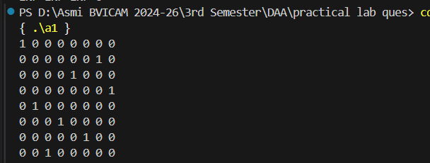

A2. Write a program to solve Sum of subsets problem for a given set of distinct numbers

#include <iostream>
using namespace std;
void printSubset(int subset[], int size)
{
cout << "{ ";
for (int i = 0; i < size; i++)
{
cout << subset[i] << " ";
}
cout << "}\n";
}
void findSubsetSum(int arr[], int n, int target, int subset[], int subsetSize, int index, bool &found)
{
if (target == 0)
{
printSubset(subset, subsetSize);
found = true;
return;
}

// If we reach end of array or target becomes negative
if (index >= n || target < 0)
{
return;
}
subset[subsetSize] = arr[index];
findSubsetSum(arr, n, target - arr[index], subset, subsetSize + 1, index + 1, found);

findSubsetSum(arr, n, target, subset, subsetSize, index + 1, found);
}

void sumOfSubsets(int arr[], int n, int target)
{
int subset[100];
bool found = false;

cout << "Subsets that sum to " << target << ":\n";

findSubsetSum(arr, n, target, subset, 0, 0, found);

if (!found)
{
cout << "No subset found that sums to " << target << ".\n";
}
}

int main()
{
int arr[] = {3, 34, 4, 12, 5, 2};
int target = 9;
int n = sizeof(arr) / sizeof(arr[0]);

sumOfSubsets(arr, n, target);

return 0;
}

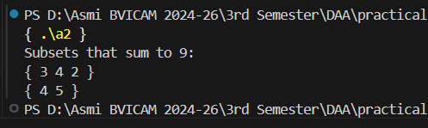

A3. Write a program to find solution for job sequencing with deadlines problem.

#include <iostream>
#include <algorithm>
using namespace std;

#define MAX_JOBS 100

// Job structure
struct Job
{
int id;
int profit;
int deadline;
};

// Swap function
void swapJobs(Job *a, Job *b)
{
Job temp = *a;
*a = *b;
*b = temp;
}

// Sort jobs in descending order of profit
void sortJobs(Job jobs[], int n)
{
for (int i = 0; i < n - 1; i++)
{
for (int j = 0; j < n - i - 1; j++)
{
if (jobs[j].profit < jobs[j + 1].profit)
{
swapJobs(&jobs[j], &jobs[j + 1]);
}
}
}
}

// Job Sequencing Function
void jobSequencing(Job jobs[], int n)
{

// Step 1: Sort jobs by profit
sortJobs(jobs, n);

int result[MAX_JOBS];
bool slot[MAX_JOBS];

// Initially all slots are empty
for (int i = 0; i < n; i++)
slot[i] = false;

// Step 2: Allocate slots to jobs
for (int i = 0; i < n; i++)
{

for (int j = min(n, jobs[i].deadline) - 1; j >= 0; j--)
{
if (!slot[j])
{
slot[j] = true;
result[j] = i;
break;
}
}
}

// Print scheduled jobs
cout << "Scheduled Jobs:\n";
for (int i = 0; i < n; i++)
{
if (slot[i])
{
cout << "Job ID: " << jobs[result[i]].id
<< " (Profit: " << jobs[result[i]].profit << ")\n";
}
}
}

int main()
{
Job jobs[] = {
{1, 20, 2},
{2, 15, 2},
{3, 10, 1},
{4, 5, 3},
{5, 1, 3}};

int n = sizeof(jobs) / sizeof(jobs[0]);

jobSequencing(jobs, n);
return 0;
}

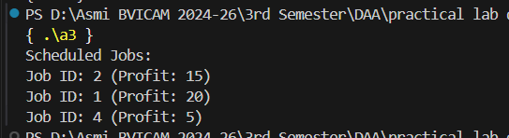

A4. WAP to implement Knuth Morris Pratt algorithm.

#include <iostream>
using namespace std;

// Function to create the LPS (Longest Prefix Suffix) array
void computeLPSArray(string pattern, int M, int lps[])
{
int len = 0;
lps[0] = 0;

int i = 1;
while (i < M)
{
if (pattern[i] == pattern[len])
{
len++;
lps[i] = len;
i++;
}
else
{
if (len != 0)
{
len = lps[len - 1];
}
else
{
lps[i] = 0;
i++;
}
}
}
}

// KMP Pattern Searching Function
void KMP(string text, string pattern)
{
int N = text.length();
int M = pattern.length();

int lps[M]; // LPS array
computeLPSArray(pattern, M, lps);

int i = 0; // text pointer
int j = 0; // pattern pointer

while (i < N)
{
if (pattern[j] == text[i])
{
i++;
j++;
}

if (j == M)
{
cout << "Pattern found at index " << (i - j) << endl;
j = lps[j - 1];
}

else if (i < N && pattern[j] != text[i])
{
if (j != 0)
{
j = lps[j - 1];
}
else
{
i++;
}
}
}
}

int main()
{
string text = "ABABDABACDABABCABAB";
string pattern = "ABABCABAB";

KMP(text, pattern);

return 0;
}

